“The Trusted 10”



Who are your “Trusted 10?”
In the table below, type the names or initials of the 10 people you trust most. Try not to include family members.
10.
9.
8.
7.
6.
5.
4.
3.
2.
1.
Name or Initials

Now, ﬁll in the rest of the table to the best of your ability.
 | Name/Initials | Gender | Race/Ethnicity | Age | Sexual Orientation | Disability: Y or N? | Religion
 | 1.
 | 2.
 | 3.
 | 4.
 | 5.
 | 6.
 | 7.
 | 8.
 | 9.
 | 10.

Follow-up Video

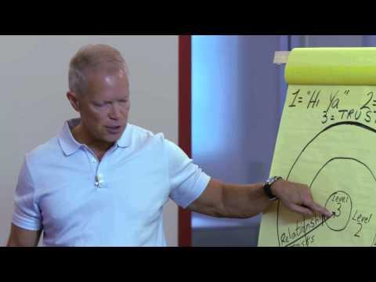
Does your “Trusted 10” align with what the man is explaining in the video? How so? Type your response in the text box below.
Response:

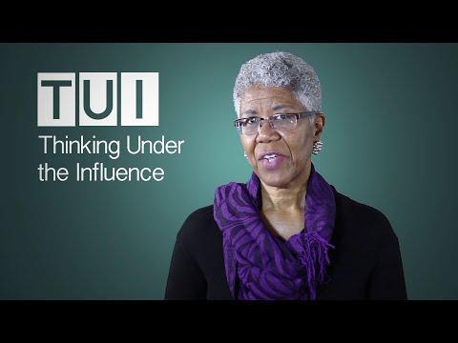
Implicit Bias: Thinking Under The Inﬂuence

What triggers you to TUI? Where did these influences on your thought come from? What concepts from this chapter can you apply to change your thought processes?
Response:

